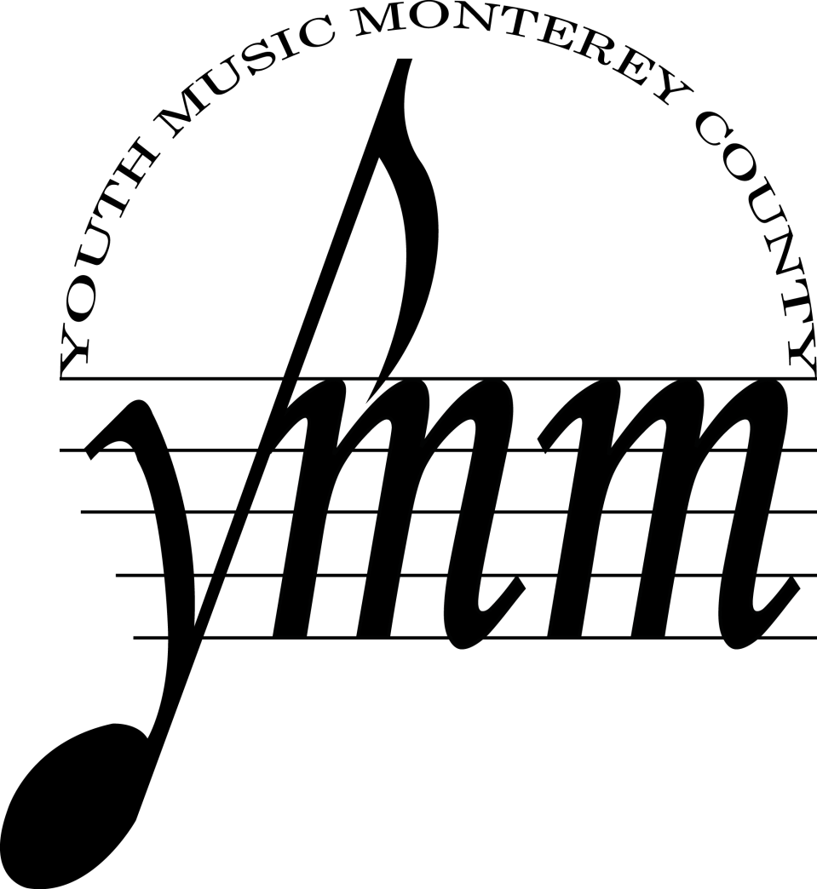

Parent & Student Handbook

The Junior Youth & Honors Orchestras of
Youth Music Monterey County

Handbook Contents

1. About Us
2. Overview
3. YMMC Expectations
School Music Programs
Private Instruction
Tuition and Registration
4. Rehearsal Information
Location, Times & Directions
Preparation for Rehearsals
Orchestra Seating and Testing
5. Audition Requirements
6. Concert Information
Concert Day Schedule
Concert Dress
Tickets
Advertising and Sponsorships
7. Hearings, Concert Seating, Concertmaster & Principals
8. Tuition Assistance
9. Tuition Costs
10. Attendance Policy
Absences
Tardiness
11. Code of Conduct
12. Parent Responsibilities
13. Accessing your music & YMMC news online
14. Musical opportunities for YMMC musicians

About Us

Our Mission
Youth Music Monterey’s mission is to inspire excellence in individual students and enrich our community by providing young people with opportunities to participate in, and gain greater understanding of, music and its performance.

...Building the Next Generation of Musicians and Music Lovers
Each year, the Junior Youth and Honors Orchestras provide approximately 100 students an opportunity to supplement their school and private music studies with high-caliber ensemble playing experience under the direction of maestro Danko Drusko. This experience helps them develop knowledge of symphonic literature as well as technical and artistic skills. The orchestras draw many of the best young musicians from throughout Monterey County - from Salinas and Monterey to Carmel Valley and Pacific Grove.

Concerto Competition
Winner(s) of an Annual Concerto Competition are selected to perform as soloist at one of YMMC’s concerts. Each student who auditions for the Concerto Competition performs his or her piece in front of an adjudicating committee. Strict rules apply; see orchestra staff for more details. The Application and Rules are made available 2-3 months before the competition date.

End-of-the-Year Awards
Each year, YMMC awards students who have shown tremendous progress and/or skill. Awards include the Ruth Fenton Award and the Pam & Chuck McGowin scholarship, and the Adel & Adelya award.

Mailing information & physical address
Youth Music Monterey County
546 Hartnell St, Suite B, Monterey, CA 93940
**Please be sure to call before visiting the YMMC office to determine if staff are on-site to meet with you.
Phone
Office: 831-375-1992
Cell: 831-293-3525 (Sue’s Cell)

Email
executivedirector@youthmusicmonterey.org (Suzanne Mudge)
office@youthmusicmonterey.org

Website
www.youthmusicmonterey.org

Overview

A message from Youth Music Monterey County
Youth Music Monterey County’s (YMMC) Junior Youth and Honors Orchestras are designed to provide high-caliber orchestral learning and performing opportunities. The success of the orchestras, however, is largely the responsibility of orchestra members and their parents.

Because an orchestra functions as a team, each orchestra member needs to do his/her part to ensure that the orchestra can reach its full potential. Likewise, YMMC parents need to help ensure that orchestra members live up to their orchestra responsibilities. As a nonprofit with limited funding, YMMC also needs parents to volunteer their time, skills, and energy to the organization.

We believe the benefits of orchestra membership are well worth a serious commitment. Moreover, it is when orchestra members make this commitment that they and the entire orchestra benefit most. With this in mind, YMMC has developed the membership policies and guidelines that are laid out in this handbook.

YMMC Expectations

School Music Programs
School music programs play a significant role in making this organization possible and we expect members to participate in their local school band or orchestra program. YMMC members are also expected to act in leadership roles within their school instrumental music programs.

Private Instruction
Private lessons are expected for students in both orchestras; members not studying privately with a qualified instructor usually do not attain the skill level necessary to grow with the orchestra. If a private teacher is not obtained and student performance is below satisfactory, the conductor retains the right to put the student on probation or possibly dismiss him or her from the concert set or the orchestra. YMM maintains a list of private instructors and private lesson assistance is available to help defray the cost of private lessons to students who already qualify for tuition assistance. Please see our Private Lesson Assistance information sheet and application.

Rehearsal Information

Important Note: All students are expected to be in their seats, ready to play, a minimum of 15 minutes before the listed start time.
Junior Youth Orchestra 4:30 pm - 6:00 pm
Honors Orchestra 6:30 pm - 8:30 pm

Preparation for Rehearsals
Members are expected to come to rehearsals musically prepared! Learn your music at home and take it to your private teacher for help as needed. Rehearsal time is not for learning your part. It is for learning interpretation, orchestral techniques, balance, and ensemble, etc. YMMC is a supplemental program that requires additional instruction and practice time outside the weekly rehearsal session. It is the responsibility of all members to bring all pertinent music and supplies to every rehearsal and performance and keep them in good condition. This includes all strings and tools needed to make simple instrument repairs. Members should also bring a pencil to all rehearsals. Music is never to be marked in ink.

Orchestra Seating & Hearings
The seating order within each orchestra section is determined by the conductor and will change at his discretion. Seating is determined based on a range of considerations including technical ability, intonation, musicality, preparation, attendance, and leadership. Woodwind, brass, and percussion seating is determined by the Music Director based on auditions, rehearsal, and input from sectional coaches. Principal string seating is determined for each concert based on auditions in the early stage of rehearsals for each concert set. Section string players will rotate seating for each rehearsal. For more details, please see page 7.

Audition Requirements

Auditions are required for all new students, students wishing to change orchestra or section, and students wishing to join Chamber Players for the first time. Auditions are held in May, August, and mid-year before the start of each rehearsal cycle.

All auditions will consist of a prepared piece of your choice, scales, and sight reading. For complete audition requirements, please see our website at: www.youthmusicmonterey.org/audition

The sight-reading selection will be provided to you at your audition and by its nature requires no extra preparation. Students who wish to practice for the sight-reading portion of the audition are encouraged to prepare by performing a new and unrehearsed passage in their daily practice session. It may be helpful to know that the music staff rarely hears perfect attempts at these excerpts but will always appreciate evidence of the right approach. Good luck!

Concert Day Schedule

YMMC’s concerts are scheduled on Sundays and families should plan on devoting most of the concert day to YMMC. The schedule for each day will be approximately as follows, but may vary to meet the needs of a particular concert:

12:00 – 1:00 pm Honors Orchestra Dress Rehearsal
1:30- 2:30 pm Junior Youth Orchestra Dress Rehearsal
3:00 PM Concert Begins (Junior Youth performs first; concert usually ends by 4:30-5:00)

Junior Youth and Honors Students are required to stay for the entire YMMC concert and watch from the audience when they are not performing. During the concert. Honors students are expected to sit in student reserved seating or with Junior Youth Orchestra parents, if there is not adequate seating to reserve for them.

Concert Dress
Members are expected to comply with the performance dress code and wear clothes that portray a professional appearance. If there is a concern about the professional appearance of the student, the student may be asked to not perform in the concert. YMMC reserves the right to determine what is acceptable.

• Junior Youth Orchestra: White shirt or blouse, dark long tie (men), black trousers or
below knee skirt, no midriff showing.
• Honors Orchestra: For women—floor length black dress or skirt or black pants and black top; for men—black suit or tuxedo with black long-sleeved dress shirt and dark long tie, or black pants with black long-sleeve shirt with dark long tie, no midriff showing.
• All: Black socks or black hose, black dress shoes.

Tickets
To help cover our concert production costs, we charge admission to concerts for all attendees except student performers. We ask each YMMC family to make an effort to sell a minimum of 6 tickets for each performance. Tickets can be purchased at rehearsals, from the YMMC office, or in the lobby on the day of the concert.

Advertising or Sponsorships
YMMC uses concert advertising and sponsorships as fund raising mechanisms for each concert. If you are interested in placing an advertisement for your company or to simply congratulate your child on his/ her performance, please contact the YMMC office. Sponsorship packets are available at the office if you would like to approach your company about making a contribution, or in-kind trade.

Concert Seating, Concertmaster & Principals

- Musician seating in the orchestra is not a ranking of ability and is based on preparation as well as what is mutually beneficial for each stand-partner and the orchestra as a whole.

- All musicians are expected to attend rehearsals on a regular basis and inform the orchestra staff in advance at least one week or earlier of any absences or tardiness. A student who is consistently absent or tardy may be removed from a principal seat.

- Students wishing to move up in their section (i.e. violin 2 to violin 1), change orchestras, or be considered for a principal position will have a chance to do so by scheduling an audition prior to each concert set. Please follow the YMMC audition requirements and inquire if any additional piece of music should be prepared for the audition.

- String seating: Concertmaster and principal chairs will be assigned for each concert based on auditions held prior to the start of rehearsals. Section strings will rotate seating for each rehearsal. Final concert seating is determined by the Music Director with input from sectional coaches.

- Wind, Brass, & Percussion seating: Principal and Co-Principal seating will be determined by the Music Director based on August auditions, input from sectional coaches, and prior year's performance. Co-Principals should expect to rotate between principal and section parts as assigned by the Music Director. Section players will rotate seating as assigned by the Music Director.

Tuition and financial assistance

Youth Music Monterey strives to keep our programs accessible to all students in our community. We work hard raising funds and writing grants to offset the costs of tuition. Our subsidized tuition rate only covers one third of the costs of running our program. We are able to offer this subsidized tuition through the generosity of local individuals and foundations. In an effort to keep our costs low, we ask that all families paying the subsidized tuition rate also make a volunteer contribution. We ask all families to select six volunteer opportunities and we will contact you as specific needs arise. Families that cannot make a volunteer commitment can still participate in YMMC programs by paying the unsubsidized tuition rate.

Rates for the 2022-2023 season are:
Subsidized (volunteer duties required): $1250
Full tuition (no volunteer duties required): $3000

Scholarships
Further tuition assistance may be available to students who demonstrate financial need. To be considered, you must complete the tuition assistance portion of the registration form and submit a copy of your most recent tax return.

Lesson Assistance
YMMC has found private lessons to be an essential tool for our students to thrive and contribute to our orchestras. We therefore expect our students to be enrolled in private lessons. In order that this will not deter any dedicated students from participating on our orchestras, we may have additional funding available to assist in the private lesson costs of students who have already qualified for full tuition assistance. Please see our Private Lesson Assistance handout or contact the office for more details.

Multi Student Discount
Families with more than one child enrolled in our program will receive a multi-student discount of an additional $100 off per student. i.e. student one $1200, student two $1100, student three $1000 etc.

Payment Plans
We offer three payment options: full year, per concert (3 payments), per month (10 payments). Payments are always due at the beginning of the pay period that you have selected. The first payment (or completed financial assistance application with tax returns) is due by the third rehearsal of the season. A student whose tuition payments are not current may be disqualified from performing. If at a point later in the year you would like to request Tuition Assistance, please contact the YMMC office for an application.

Chamber Ensembles
YMMC offers several chamber ensembles to allow our students additional opportunities. We currently offer Brass Ensemble, Woodwind Ensemble, and a mixed instrument Chamber Players. The costs of these programs are covered in tuition and are offered to our students at no additional expense. Please see the Parent/Student Guide or contact the office for more details.

Instrument Rentals
YMMC is also able to offer instrument rentals to our students. We currently have a full inventory of orchestral string instruments as well as a limited selection of woodwind and brass instruments.
Rentals are $20 per month and require a $50 refundable deposit. Students asked to use an auxiliary instruments (A & Eb clarinets, piccolo, English horn, etc.) in a YMMC concert may borrow the instrument without a rental fee, however, a refundable deposit is still required.

Attendance Policy

Absences
Learning professional responsibility is an important part of YMMC’s program for musical excellence. Absences from rehearsals are detrimental to everyone’s musical progress because an orchestra can only excel as a team. Absences often leave the orchestra without a critical part covered. With this in mind, YMMC maintains the following attendance policies. Please read very carefully:
- Members are expected to be present and on time for all rehearsals and concerts. “On time” means arriving at least 15 minutes early and being signed in, seated, tuned, warmed up, and ready to play at least 10 minutes before the listed starting time.

- The dress rehearsal (Wednesday immediately preceding the concert) and the soundcheck rehearsal (day of the concert) are mandatory. Students who miss either of these rehearsals will not be permitted to play in the concert. Students and parents should mark these dates on their calendar and plan ahead to ensure that they are able to participate in the concert.

- Members with two (2) or more absences from rehearsals and retreats in a single concert set may be required, at the Music Director’s discretion, to demonstrate mastery of the music prior to participation in the concert. It is your responsibility to keep track of absences and to be prepared if you are asked to perform a designated passage.

- The Absence Notification form must be turned in to the orchestra manager for ALL absences. The Absence Notification must be submitted no less than one week prior to an intended absence. The form can be completed online at www.youthmusicmonterey.org/absence. In the case of unexpected illness or family emergency, please inform the executive director at least two hours before the rehearsal by calling 831-293-3525.

- Members are asked to plan carefully so that they will not miss rehearsals, dress rehearsals, and concerts.

- Junior Youth Orchestra musicians must stay for Honors Orchestra performances, and Honors Orchestra students must attend Junior Youth Orchestra performances. Absence from a concert without a reasonable excuse may be cause for dismissal from the orchestra.

Tardiness
Members are expected to arrive at least 15 minutes before the scheduled downbeat at all rehearsals in order to allow time for warm-up, tuning, and attendance sign-in. Members must be in their seats, ready to play, a minimum of 10 minutes before the listed start time.
• Attendance will be taken before each rehearsal. If you are not signed in and in your seat five minutes before rehearsal begins, you will be counted as tardy.
• Leaving early counts as tardiness.
• Two tardies will be counted as one absence.
• If you feel the tardiness warrants special consideration, it must be immediately reported to the Orchestra Staff.

Code of conduct

Each orchestra member is considered an ambassador for the organization because the behavior of any one member reflects upon the entire group. In this capacity, members are expected to come to rehearsal well-prepared, use good manners, display common courtesy, and show consideration for others. Additionally, members are expected to give their full attention and respect to the conductor, coaches, orchestra staff, and volunteers.

Orchestra members who exhibit problems with behavior, attendance, musical preparedness, or engage in any other behavior that interferes with rehearsals or the overall functioning of the orchestra will be given one Verbal Warning. If the problem(s) continue after a member has received a Verbal Warning, he/she will be placed on probation, the member’s parents will be notified, and potential Dismissal from the orchestra will be discussed. The Conductor reserves the right to dismiss any member who has received a Verbal Warning. Once dismissed, a member may reapply for the following concert set but readmission will be contingent upon YMMC staff approval.

Parent Responsibilities

Parents are obligated to help students fulfill their musical responsibilities to YMMC by encouraging at-home practice, 100% attendance, punctuality, and courtesy at all times. Active parental support helps foster a serious commitment to excellence.

Parents will be assigned to volunteer committees and asked to support YMMC through volunteer hours. Please remember that tuition only covers one-third of the cost of YMMC’s orchestra budget. To keep staffing costs as low as possible, your commitment to volunteer service is imperative. Volunteer signups are currently coming via Sign-Up Genius.

There are many administrative and fund-raising volunteer opportunities offered throughout the year and we appreciate your time to help with projects such as mailings, distributing promotional materials, and database entry. YMMC also asks for volunteer positions to be filled that require a little more responsibility but are extremely valuable to the success of YMMC. Many of the key positions are listed below.
• Volunteer Coordinator
• Concert Volunteer
• Bring Snack
• Assistant Music Librarian
• IT/Computer Tech
• Mailings
•Distribute materials/flyers
• Merchandise Sales
• Graphic Design/Artwork
• Obtain Advertisements for Program
• Fundraising Committee Members
• or contact the YMMC Office for a Complete List of Volunteer Opportunities

Accessing your music and YMMC News Online
We will provide the DropBox link in order to access the music. All musicians must download/print their music and begin practicing. YMM will not provide printed copies of music so please be sure to print and bring your music to the first rehearsal. Sheet music links can be found in the members section of the website. Please be sure to download, print, and practice your music before the first rehearsal.

Please visit:
www.youthmusicmonterey.org/music

YMMC will also post timely information on this page and links to pertinent information.

Musical Opportunities for YMMC Students

YMMC offers several opportunities for its musicians beyond the Junior Youth & Honors Orchestras. Please refer to the YMMC website for specific information on each ensemble, and how to audition and apply. There is no additional tuition for musicians wishing to participate in these ensembles.

Brass Ensemble
YMMC brass players work in small groups to prepare for chamber music performances in the community, a spring recital, and at the YMMC spring concert. The ensemble uses flexible instrumentation to allow students to perform anything from duos to large brass ensemble compositions. Students attend weekly rehearsals to work on techniques specific to brass playing, as well as addressing tone, balance, blend, style, and other topics not covered in full orchestra rehearsals.

Chamber Players:
The YMMC Chamber Players are committed to providing a professional model of music making for motivated young musicians. Wishing to instill a sense of personal responsibility, community and appreciation for audiences and supporters, the Chamber Players are committed to bringing performances into the community, collaborating with other organizations and giving back. The Chamber Players travel to public schools in south Monterey County, and perform for local retirement communities in order to bring music to people throughout the community. Members of the YMMC Honors Orchestra, Vocalists, Alumni and Pianists are invited to participate.

Woodwind Ensemble
Students work in small groups to prepare for chamber music performances in the community, a spring recital, and at the YMMC spring concert. The ensemble uses flexible instrumentation to allow students to perform anything from duos to woodwind quintets, to large woodwind ensemble compositions. Weekly rehearsals help students to work on techniques specific to woodwind playing, as well as addressing balance, blend, style, and other topics not able to be covered in full orchestra.

